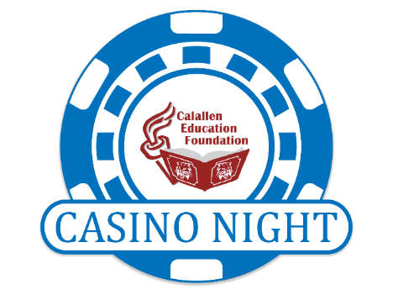
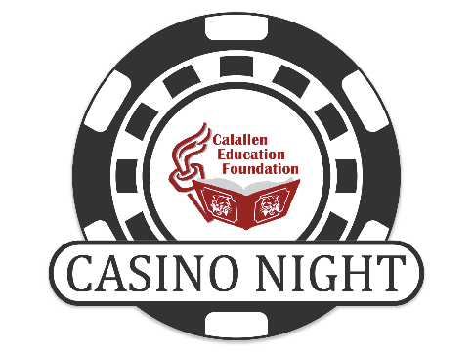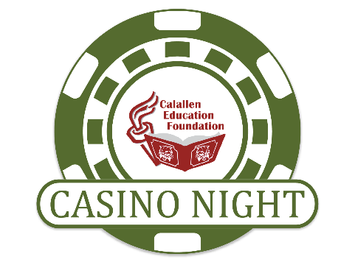
2023 Auction Donation Form
Live Auction Donation(s) or Silent Auction Donation(s)

The Calallen Education Foundation (CEF) will be hosting the 11th Annual Casino Night
Fundraiser on Saturday, February 18, 2023 at the Al Amin Shrine Crystal Ballroom. Food, casino game tables, music, live and silent auctions will be provided for an exciting evening of entertainment and fun. All proceeds benefit the Calallen Education Foundation to support innovative and inspiring educators in the classroom.
The silent auction will be online and open for bidding from February 10 – February 18.
As a 501(c)(3) charitable organization the Calallen Education Foundation is able to fulfill its’ goals through strong community partnerships and generous donations of local businesses and community.

Print clearly and return to Calallen Education Foundation with donated item:

Item(s) Donated: ______________________________________________________ Value: ______________________

Item(s) Donated: ______________________________________________________ Value: ______________________

Business Name (if applicable): ______________________________________________________________________
Contact Person: ______________________________________________________________________________________
Address: ______________________________________________________________________________________________
Phone: ___________________________________________Email: _____________________________________________
Calallen Education Foundation EIN: 26-4252668
4205 Wildcat Drive
Corpus Christi, TX 78410

